**Homework 1**

**Wellington Martinez**

**Jose Alcivar**

**Erasmo Zurita**

1. **For each of the following problems, determine as group, which search method: BREADTH FIRST or DEPTH FIRST would you use? In each case justify the answer and report the conclusions.**

**A program for playing tic-tac-toe.**

We would use depth first, because once time we realice one movement, the next player try to block these movement, the sequence of the steps that are organized level at level and the leaves are boards where it can’t do any movement more, or a player win, we need to access to these levels more quickly.

**A program for solving a maze.**

Depth first:

We would use depth first, because each state of the tree could represent a position separated by a periodic distance in the maze. If the maze have the exit at the bottom,

we can find it more quickly crossing the maze vertically than horizontally.

**A program to determine if 2 mathematical expressions are equivalent.**

We would use breadth first, because the states of the node can be representations of the different forms of an expression, is more quickly to find an expression in the middle of the tree.

**2. The decision for doing DATA or GOAL DRIVEN search is generally based on the structure of the problem. As a group, discuss and report the conclusions about the characteristics of the structure that the problems should have. Report at least 3 characteristics for data driven and 3 for goal driven search.**

**3 characteristics for data driven.**

* When the problem gives me a lot of facts or information to which I can apply the rules of the game to get new facts that allow or help me to reach the goal or objectives.
* there is a great difficulty, at the moment to form a hypothesis.
* it is necessary to make a management of the data, so that the system interprets them at the beginning of the program, this entails a great difficulty.

**3 characteristics goal driven search.**

* When the objective or goal of the problem is clear and can be represented in states.
* When the rules are in line with the facts of the problem, which allows me to achieve the objectives that I can pursue.
* When the problem doesn't give me much information to work with but the necessary information can be obtained starting from the objective to achieve. I can start from there to see what facts are necessary to achieve this objective

**Given the following tree and applying DEPTH FIRST Search, find the path to node Q, starting from node A.**

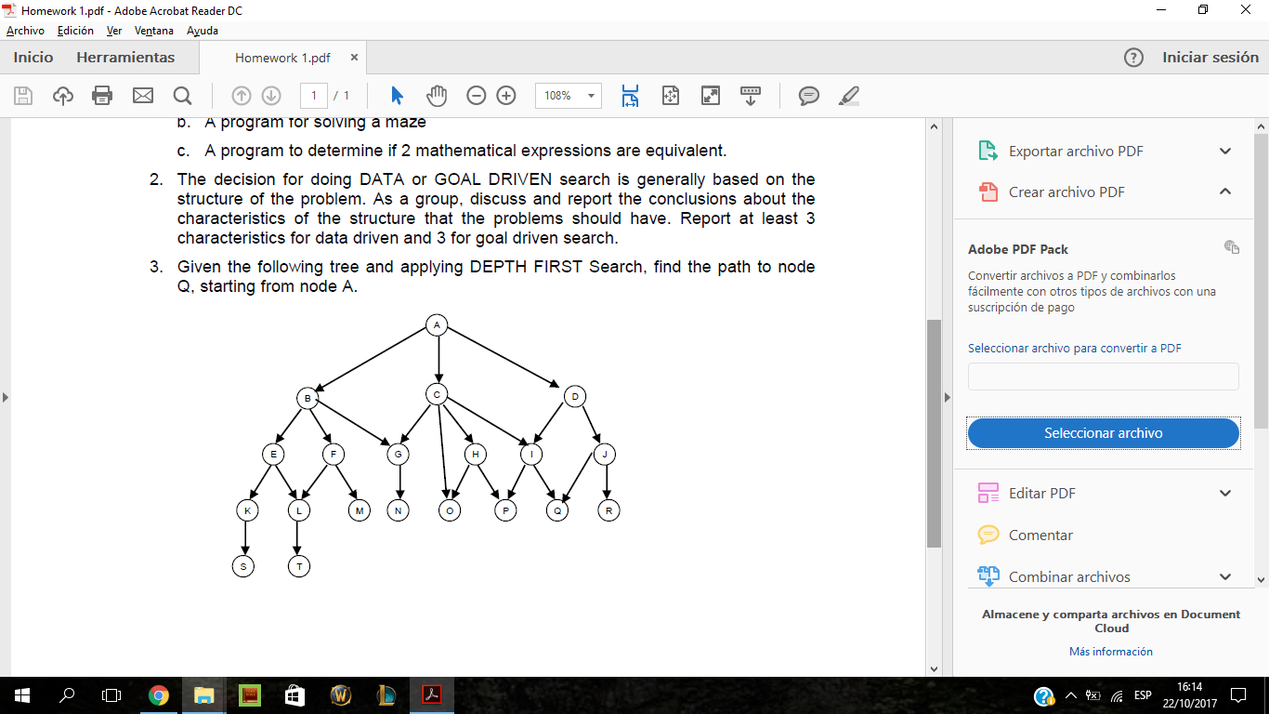

TOMAMOS EL CAMINO POR LA DERECHA :

1. Open = [A]

Close = [ ]

X = A

2. Open = [D,C,B]

Close = [ A ]

X = D

3. Open = [J,I,C,B]

Close = [ D,A ]

X = J

4. Open = [R,Q,I,C,B]

Close = [ J,D,A ]

X = R

5. Open = [Q,I,C,B]

Close = [ R,J,D,A ]

**X = Q**